**Cambio del swappiness**



**Instalación de MariaDB**

**sudo yum install mariadb-server**

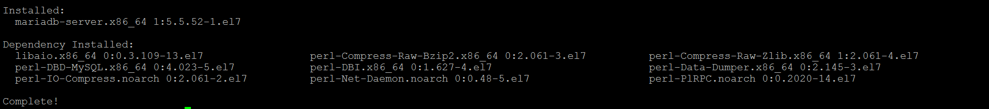



**Instalación de Conector MariaDB**

[centos@ip-172-31-5-130 ~]$ tar zxvf mysql-connector-java-5.1.42.tar.gz

**Creación de bases de datos para los Cloudera Services**

create database rman DEFAULT CHARACTER SET utf8;

create database metastore DEFAULT CHARACTER SET utf8;

create database sentry DEFAULT CHARACTER SET utf8;

create database nav DEFAULT CHARACTER SET utf8;

create database navms DEFAULT CHARACTER SET utf8;

grant all on amon.* TO 'amon'@'%' IDENTIFIED BY 'amon_password';

grant all on metastore.* TO 'hive'@'%' IDENTIFIED BY 'hive_password';

grant all on sentry.* TO 'sentry'@'%' IDENTIFIED BY 'sentry_password';

grant all on nav.* TO 'nav'@'%' IDENTIFIED BY 'nav_password';

grant all on navms.* TO 'navms'@'%' IDENTIFIED BY 'navms_password';

**Instalación Cloudera Manager**

JSK

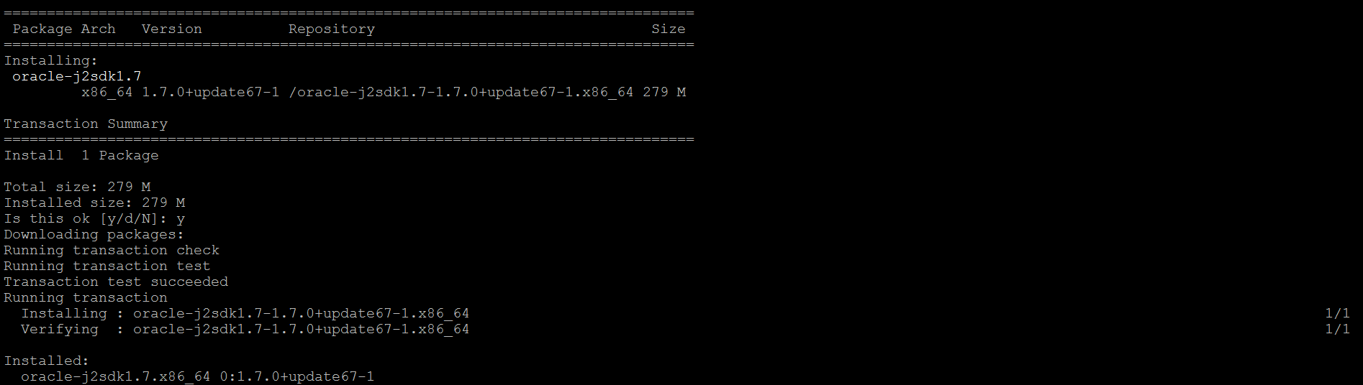

Daemons

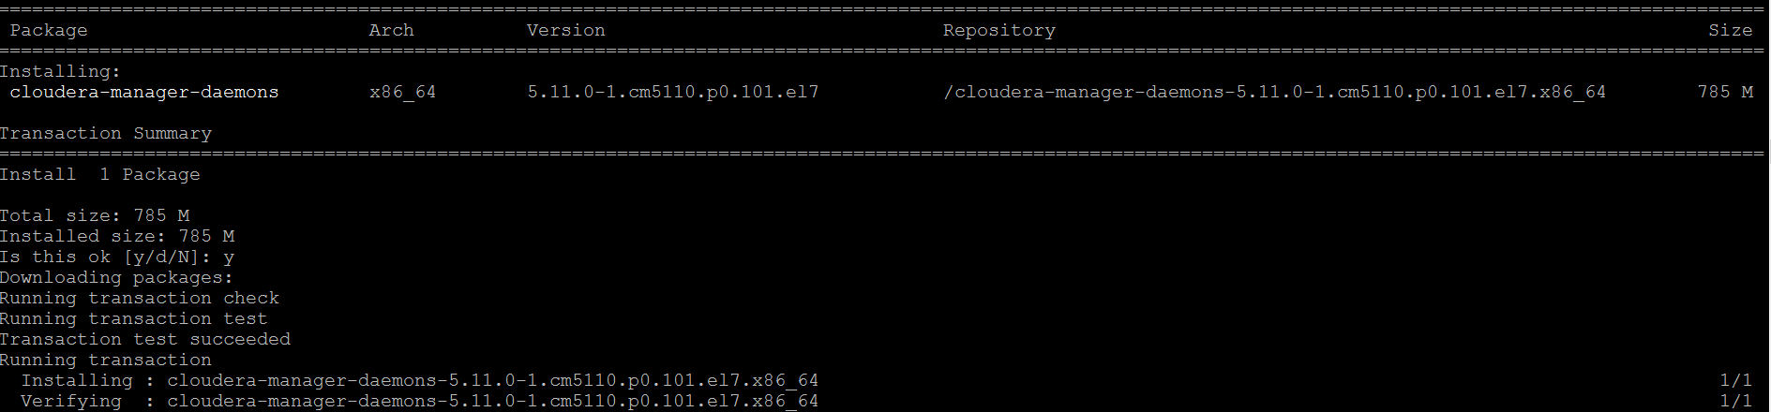

**Manager Server**

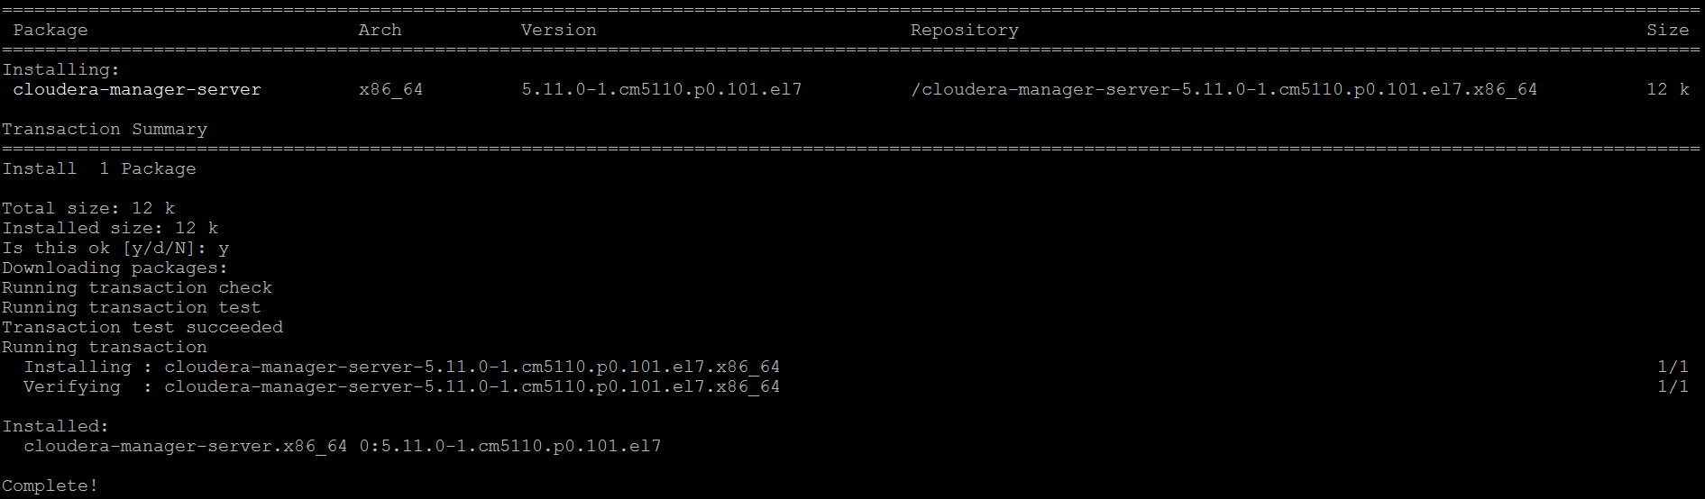

**Preparación de la Base De Datos de CM**



**Cloudera Manager**

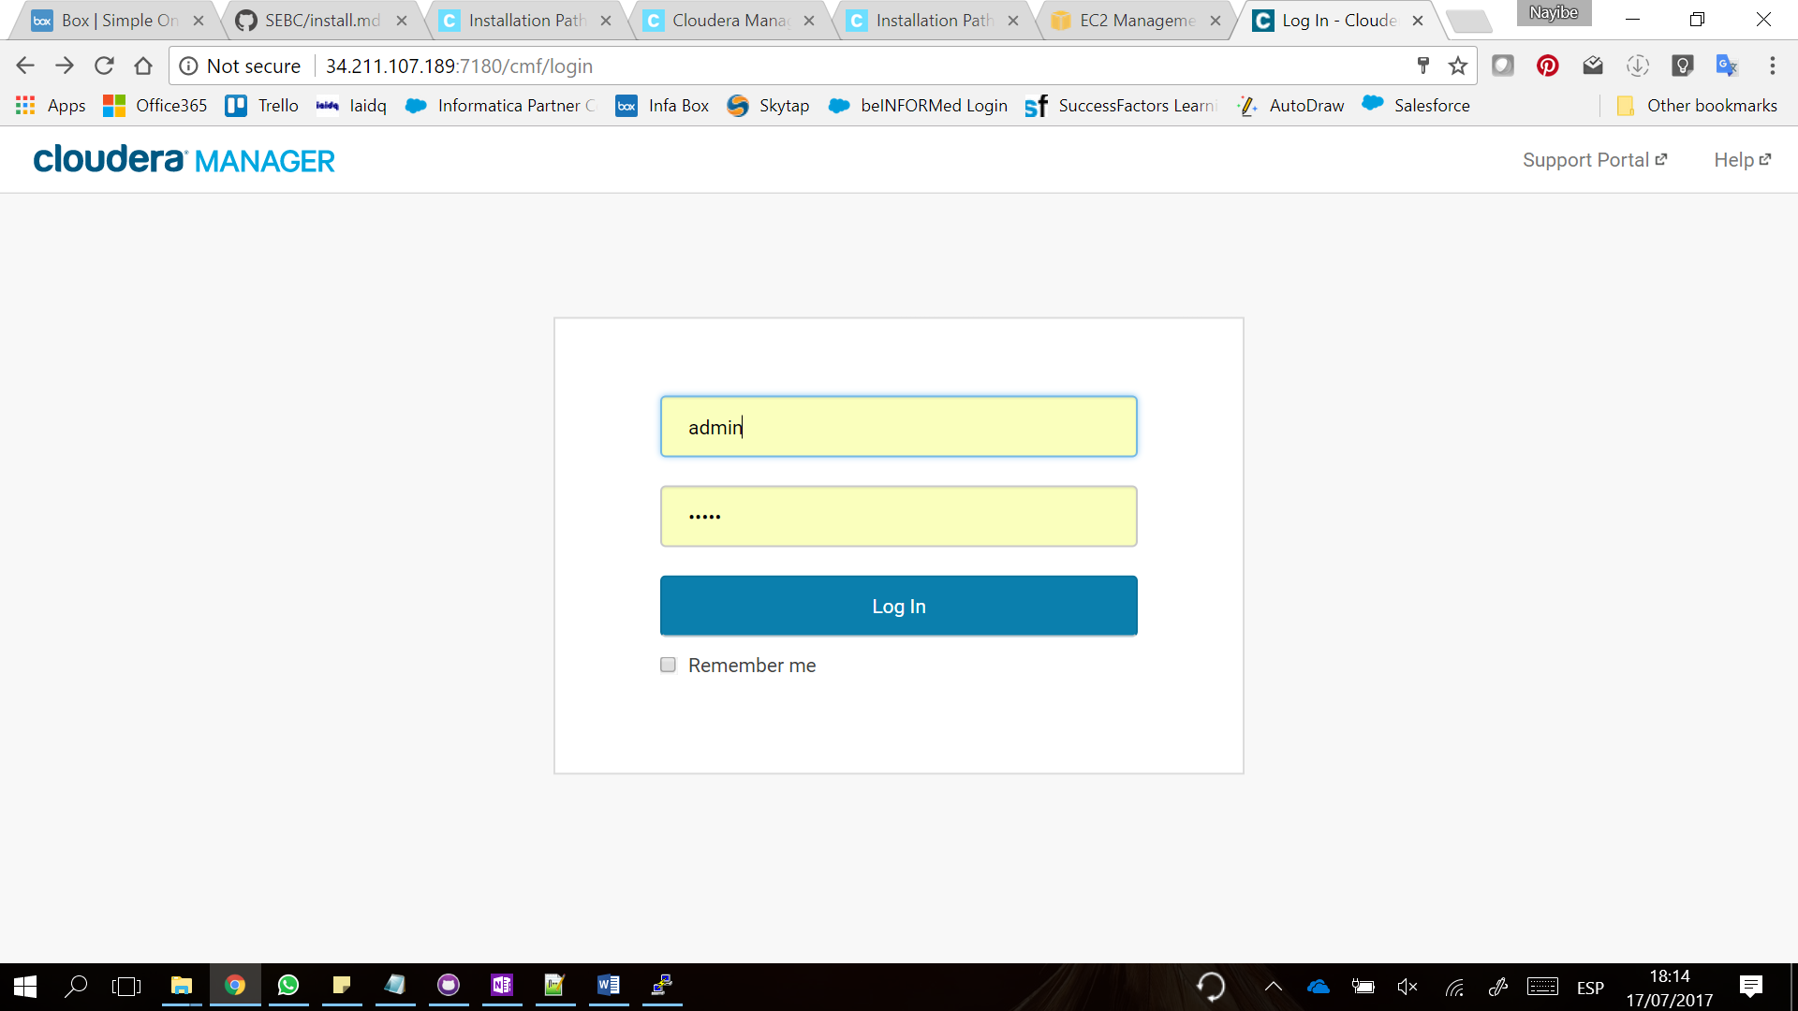

**Servcios de la consola**

* **CMS**
* **ZK**
* **HDFS**
* **Yarn**

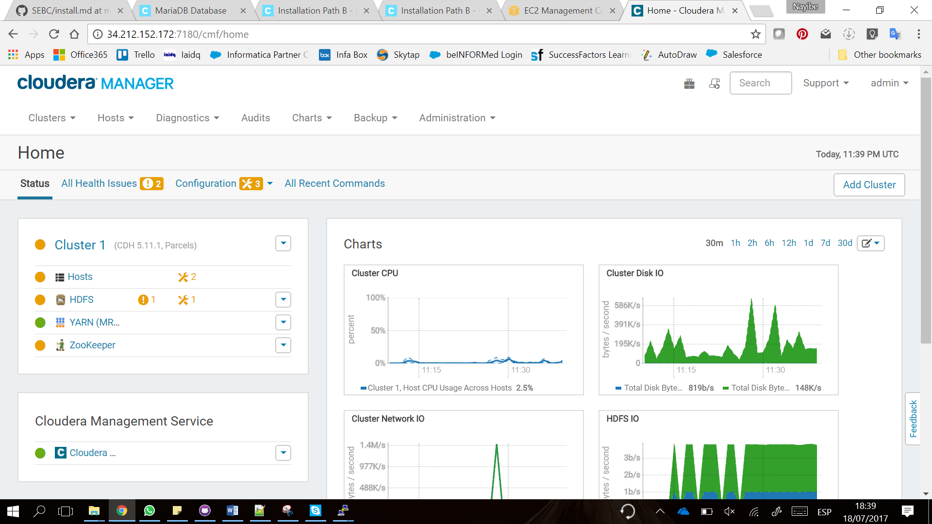

**Consola instalada**

